Report Launch Social Media Kit
Reducing Stigma: Exploring the Intersections Between Trauma, Race, and Criminalization

Twitter & Instagram Handle: @WomanACT @Efry_Toronto/@ElizabethFryToronto
Facebook & LinkedIn Tag: Woman Abuse Council of Toronto, Elizabeth Fry Toronto
Report Link: https://womanact.ca/publications/reducing-stigma/
Project Webpage: https://womanact.ca/projects/reducing-stigma-and-improving-access-to-women-with-experiences-of-criminalization-and-trauma/

Report Graphic
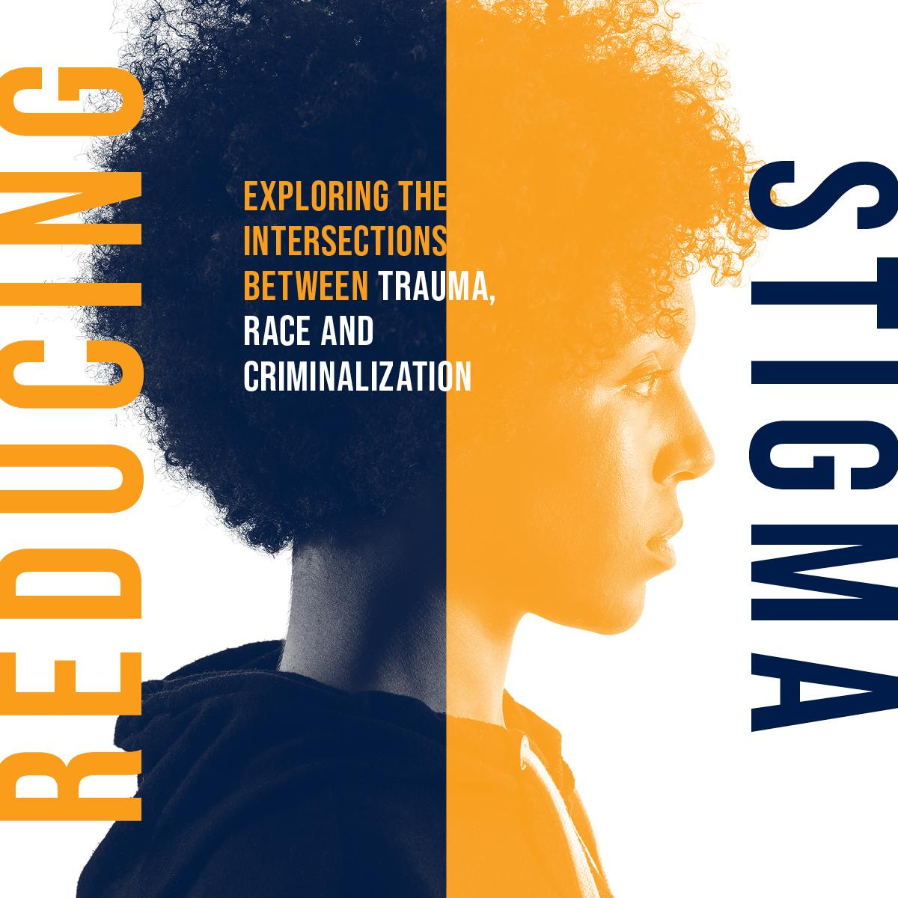
Sample Twitter Posts

- New research from @WomanACT and @Efry_Toronto highlights the impact of intimate partner violence and racism on the lives of racialized women and gender diverse people in the criminal justice system. https://womanact.ca/publications/reducing-stigma/

- New research from @WomanACT and @Efry_Toronto found 53% of women & gender diverse people were coerced into criminalized activities by their partners or turned to criminalized activities to help cope with violence. https://womanact.ca/publications/reducing-stigma/

- New research from @WomanACT and @Efy_Toronto found racialized women and gender diverse people were in greatest need of help when leaving the criminal justice system, but faced the greatest barriers to services at this time.
https://womanact.ca/publications/reducing-stigma/

Sample Facebook & LinkedIn Posts

- New research from @Woman Abuse Council of Toronto and @Elizabeth Fry Toronto highlights the impact of intimate partner violence and racism on the lives of racialized women and gender diverse people in the criminal justice system.

The research found that intimate partner violence was a key pathway into the criminal justice system among survivors, including being coerced into crimes or turning to criminalized activities, like theft, to help flee violence.

The research also found that women and gender-diverse people faced stigma and discrimination based on their race and criminal record by services and people when trying to get help.
Learn more: https://womanact.ca/publications/reducing-stigma/

Sample Newsletter Post

New evidence on intimate partner violence and criminalization - This month, the Woman Abuse Council of Toronto (WomanACT) and Elizabeth Fry Toronto released a new research report that highlights the impact of intimate partner violence, trauma, and racism on the lives of racialized women and gender-diverse people in the criminal justice system. The full report is available on their website: https://womanact.ca/publications/reducing-stigma/

Fast Facts – Build your own post with these key data points

- 53% of women reported that intimate partner violence had directly contributed to their criminalization.
- Women face stereotyping within service organizations based on their race and involvement in the criminal justice system.
- Women reported that they do not seek out services or help because of shame and fear of judgement over their criminal record.
- Women described being directed away from organizations they want to engage with and directed towards services seen as predominantly for those in the criminal justice system.
- Women want service providers and organizations who understand the complex relationship between trauma and criminalization.

