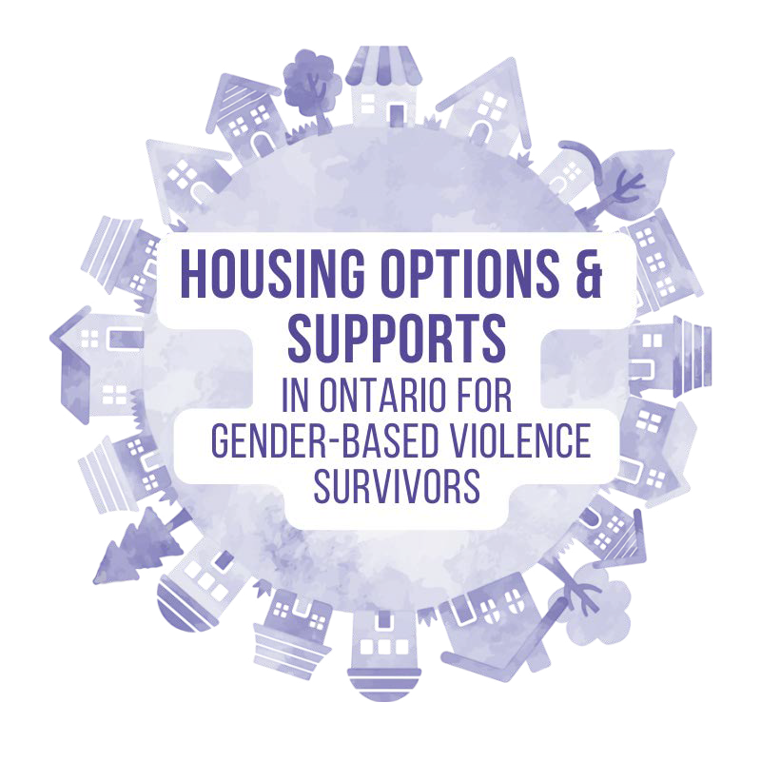


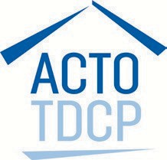

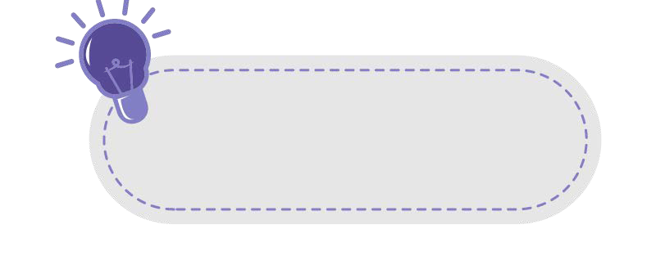
This resource provides a snapshot of housing support available in communities across Ontario that may be helpful for survivors of gender-based violence (GBV) and their children. There are variations in the supports available depending on where you live.

Quick Tips
- If you are a survivor of violence or abuse, support is available in navigating housing systems in Ontario. Visit mulberryfinder.ca to find a Transitional & Housing Support Program (THSP) in Ontario, or a GBV shelter. Learn more about Transitional Supports: bit.ly/UnderstandingTHSPEnglish
- Legal advocacy is available for survivors of abuse and violence in Ontario in relation to housing rights. There are Legal Clinics across Ontario that can often provide support and advocacy related to the below housing supports. Find a legal clinic here: bit.ly/ LegalClinicsOntario. You must live in the area that the clinic is located in to access service. It may be helpful to connect with legal
support related to:
- Being removed from a waitlist for a housing support
- Being told you are not eligible for a housing support
- Fighting an eviction from a landlord or social housing provider
- Ending your tenancy
- Tenant applications
  - Learn more about moving out and how to legally terminate your housing from Steps to Justice: bit.ly/StepstoJusticeEndingLease
  - If you are experiencing GBV, you can terminate your tenancy early. Learn more about how to end your lease early on CLEO’s website: bit.ly/MovingOutGBV
  - Most housing options have the following eligibility criteria:
    - At least one person applying is over age 16
    - No one living in the home has a current removal order
    - Everyone living in the home is either a Canadian citizen, permanent resident, refugee, or someone who has made a refugee claim or applied for permanent residence (1)
Affordable Housing Supports in Ontario for Gender-Based Violence Survivors 1



      - Even if you don’t have all of the documentation typically needed under the eligibility criteria, this can sometimes be overlooked, for example in cases where trying to get the documents puts someone at risk of harm

      - It is encouraged that survivors discuss the housing option that is the best fit for their needs with a housing worker.


Rent-Geared-To-Income (RGI) Housing:

What: RGI housing is a type of subsidized/affordable housing offered by cities, districts, counties or regions across Ontario. In RGI housing, rent is calculated based on household income. Typically, this is calculated at 30% of the household’s monthly net income.

Who: Households with lower incomes. Each service manager decides the income level limits and can approve exceptions.

Where: Find your local service manager: bit.ly/FindServiceManagerOntario. General RGI wait times are extremely high across Ontario as there is a housing shortage.

The application form may include all available RGI housing, or there may be different applications for specialized RGI housing such as Transitional Housing for survivors of GBV and Indigenous Housing Services.

Why: Accessing RGI can make rent more affordable.

How: The application will include requests for an identification document like a birth certificate, and a Notice of Assessment from the Canadian Revenue Agency to confirm income. If you don’t have these documents, a THSP worker can help you to obtain them or explain to the service manager why this isn’t possible.
Affordable Housing Supports in Ontario for Gender-Based Violence Survivors 2

Special Priority Program (SPP):

What: SPP aims to provide survivors of gender-based violence and human trafficking with quicker access to RGI housing. However, wait times can still be significant and vary across communities.



Who:
Applicants must be:
  - Aged 16 or older
  - A survivor of *abuse or a person living in the same household as the survivor of abuse or trafficking
  - Eligible to receive RGI housing
    - *Abuse includes many types of abuse including physical or sexual violence, controlling behaviour, intentional destruction of property, financial abuse, child abuse, spiritual abuse, technology- facilitated violence, forced labour, forcible confinement, threat or use of force.
    - The “abuser” may be: a current or past intimate partner of someone in the household, a family member of someone in the household, an immigration sponsor of someone in the household, or a perpetrator of human trafficking
When: Apply for SPP within three months of leaving an abusive relationship/violent or unsafe housing

Why: Apply for SPP to reduce the wait for RGI housing. This priority access is based on your increased risk of violence/abuse following separation from the person causing harm.

Where: Although applications can be made directly to housing authorities, it is helpful to first connect with a GBV worker who has specialized knowledge of housing. Find a Transitional and Housing Support Worker (THSP) near you by visiting www.mulberryfinder.ca/THSP. You do not need to stay in a shelter to access this program.

How: Required documentation includes proof of cohabitation within last 3 months and a support letter
  - Connect with your local GBV organization or housing manager for assistance with completing the SPP application

Affordable Housing Supports in Ontario for Gender-Based Violence Survivors ³


- You do not have to return to an abusive situation to try to obtain any documentation

- If you do not have the available documentation or fall outside of the application deadlines a GBV organization or legal support may be able to advocate on your behalf
- A support letter can also be provided by a doctor, nurse, lawyer, teacher, Indigenous elder, social worker or psychotherapist
Other Important Facts:
- Some eligibility rules are determined by local housing service managers and vary across communities. For example, differences in how they use their judgment to consider:
  - Income and asset limits
  - Missed timelines (for example, not living with the abusive person within the 3 months before the application)
  - Missing documents
  - Previous rent arrears
- Some portals require regular logins to show interest in units and if you do not login you can lose your spot. Many survivors, especially older adults, find this challenging. A THSP worker can help to create a plan of how to manage this. Find a THSP worker by visiting www.mulberryfinder.ca/THSP
- Connecting with a GBV support and the housing manager can help resolve issues with applications through use of discretion

Canada-Ontario Portable Benefit (COHB):

What: COHB is a temporary/time limited portable benefit that can be used to access housing through private market rentals. The amount of COHB is calculated based on the difference between 30% of your household income and 80% of the average market rent in the area. The availability and amount of COHB varies across areas (2).
  - Portable means it can move with you - you do not need to stay in a specific community to use this benefit, and can continue to access this benefit if you choose to move to a different rental unit or a different community
  - COHB can be paid directly to landlords by service managers.
Affordable Housing Supports in Ontario for Gender-Based Violence Survivors ⁴


Who: Applicants must be eligible to be on the social housing wait list.

Priority is given to applications from survivors of domestic violence, human trafficking, those who are homeless/facing homelessness, Indigenous persons, seniors, people with disabilities and households who have stopped receiving assistance as a result of changes to other housing support programs. In some circumstances, homeowners may be eligible.

You do not need to stay in a shelter to access COHB.

When: Technically you can apply for COHB at any time, however sometimes it is only available for a few months at a time. Check with your local service manager if applications are being accepted.

In many cases you do not need to move to receive the COHB, it can be used to pay the rent where you are currently living.

COHB must be renewed annually. Each year by April 30th, all income earners must submit a federal income tax return to allow the monthly benefit to be calculated so they can continue to receive the benefit.

Where: Contact your local service manager: bit.ly/FindServiceManagerOntario. You can also connect with a local GBV service for assistance with determining eligibility and applying for the COHB. COHB participants can contact the ServiceOntario Information Centre for more info on the calculation of the benefit, or to request a redetermination of the benefit amount: www.ontario.ca/locations/serviceontario.

Why: Use COHB to offset the costs of a private rental. You will still need to cover a portion of the rent. If you accept COHB, you will be removed from any existing RGI wait lists, whether or not you applied to RGI through the Special Priority Program. COHB can be helpful when looking for flexibility or time-limited housing or to maintain housing. Please note it is not known if COHB will be available beyond 2029.

How: Information requested during the application process will include an Income Tax Assessment and consent to share information with the Canadian Revenue Agency (CRC).
Affordable Housing Supports in Ontario for Gender-Based Violence Survivors 5


Affordable Housing Supports in Ontario for Gender-Based Violence Survivors
6


Municipal Rent Supplements/Rent Subsidies:

What: Rent supplements/subsidies are a temporary and time-limited benefit provided to low-income individuals and families at risk of homelessness. Funds are provided that can help pay for rent in the private market, but often this is short-term.

Who: This varies across areas, but survivors of GBV are sometimes identified as a priority group.

When: This also varies across areas. Time limits may be based on your current needs. Sometimes long term options are available.

Where: Contact your local service manager: bit.ly/FindServiceManagerOntario. Rent Supplements/Subsidies may be available directly from your municipality.

Why: You are currently homeless, or there is a risk of losing your housing and becoming homeless.

How: Application process varies across communities.


 Transitional Housing, Supportive Housing and Second- Stage Housing
What: Transitional Housing, Supportive Housing, and Second Stage housing programs offer short- term affordable housing accommodations during transitional periods/stages.
- Rental rates are often geared-to-income.
- Wrap around supports including counselling, employment and income supports among others, may be available through the transitional housing organization
- Additional safety measures (physical building features, restrictions on who can be in the building) may also be in place for transitional and second stage housing designed for survivors of GBV.
Who: Transitional, Supportive and Second Stage housing is often specialized towards a specific group that is transitioning to longer-term housing. This includes Transitional, Supportive and Second Stage Housing designed for survivors of GBV who are leaving abusive situations and transitioning out of shelter programs. In some areas, there is also specialized Transition, Supportive and Second Stage housing available specific to age, culture, or ability. For example, Second Stage Housing for Indigenous women.

When: Several months + (this may vary depending on organizational policies and available housing options)

Where: Transitional and Second-Stage Housing organizations are located across Ontario. Some transitional housing units are connected directly to local shelters and may be located within close proximity to the shelter. Transitional housing organizations may operate distinctly from the local shelter and units may also be located elsewhere in the community.

Why: Transitional and Second Stage Housing can be helpful for survivors seeking temporary/interim housing while they work towards permanent housing, as well as those seeking additional support and safety related to their experiences of violence.

How: Applications are typically handled directly by Transitional Housing Organizations. Visit mulberryfinder.ca to:
- Learn more about the available transitional, supportive, or second stage housing options in your community
- To find additional housing resources, such as transitional housing support workers visit mulberryfinder.ca
Affordable Housing Supports in Ontario for Gender-Based Violence Survivors 7



Contact your local housing Service Manager:

(add your local housing service manager contact information here)

See a list of all Service Managers: bit.ly/FindServiceManagerOntario

Contact your local GBV organization:

(add your local GBV organization contact information here)

See a list of all Transitional Programs in Ontario: www.mulberryfinder.ca/THSP

Access this resource in other languages: www.mulberryfinder.ca/HousingSupports

References:
- Adapted from Steps to Justice, Accessed from: https://stepstojustice.ca/steps/housing-law/3-learn-more-about-how-to-apply
- COHB Guidelines, Accessed from: https://www.msdsb.net/images/ADMIN/correspondence/2020/COHB_Program_Guidelines_Final.pdf

Affordable Housing Supports in Ontario for Gender-Based Violence Survivors 8

